Project Report

1. INTRODUCTION
1.1 Project Overview

Project Title: SmartSorting – AI-Based Fruit and Vegetable Freshness Classifier Team
Members:

K Saketh Ram– Team Lead

V Yashaswini

M Shobha rani

K Ankitha

Overview:
SmartSorting is a machine learning-based web application designed to automatically classify fruits and vegetables as fresh or rotten using image input. By leveraging transfer learning with the VGG16 model, our system can accurately identify the freshness of 29 types of fruits and vegetables. The project uses Python, OpenCV, TensorFlow, Keras, and a Flask web framework to build and deploy the model. Users simply upload an image, and the model returns the result in seconds.

This solution is particularly useful for grocery store owners, warehouse operators, and large-scale food vendors who handle large volumes of produce and need a fast, automated method for sorting.
1.2 Purpose
Project Purpose:

The primary goal of SmartSorting is to provide an efficient, reliable, and user-friendly tool to help in reducing food waste and improving sorting accuracy by automatically detecting spoiled fruits and vegetables. Manual sorting is time-consuming, labor-intensive, and prone to error. Our AI-powered model solves this problem by offering:

Instant classification from image input

Reduction in labor costs and time

Improved supply chain efficiency

Support for large-scale fruit/vegetable handling operations

2. IDEATION PHASE
2.1 Problem Statement
2.2 Empathy Map Canvas
2.3 Brainstorming

3. REQUIREMENT ANALYSIS
3.1 Customer Journey map
3.2 Solution Requirement
3.3 Data Flow Diagram
3.4 Technology Stack

4. PROJECT DESIGN
4.1 Problem Solution Fit
4.2 Proposed Solution
4.3 Solution Architecture
- PROJECT PLANNING & SCHEDULING
  - Project Planning
- FUNCTIONAL AND PERFORMANCE TESTING
  - Performance Testing

7. RESULTS
7.1 Output Screenshots

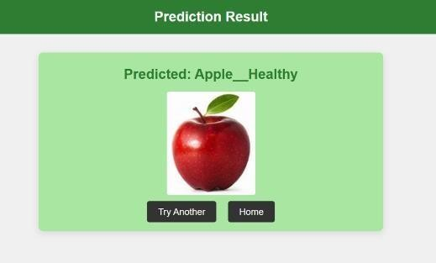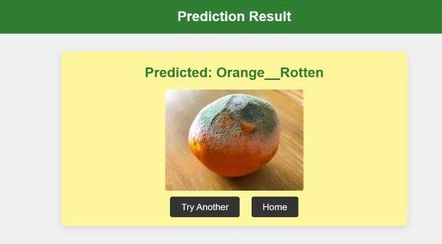

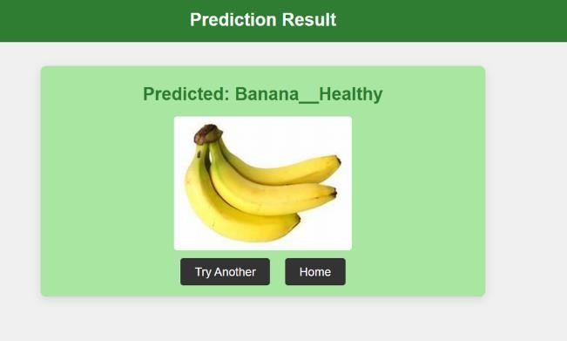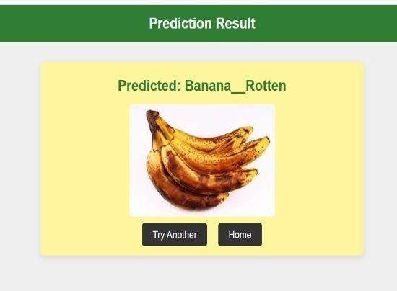

8. ADVANTAGES & DISADVANTAGES

✅ Advantages of SmartSorting Project
- Accurate Sorting: Uses a trained VGG16 model achieving up to 94% accuracy in classifying fresh and rotten fruits/vegetables.
- Time-Saving: Automates the manual process of sorting, saving time for farmers, vendors, and retailers.
- Accessible Anywhere: The Flask web app can be hosted online and accessed from any location with internet.
- User-Friendly Interface: Simple UI for users to upload images and get instant predictions.
- Scalable Solution: The model and app can be expanded to include more classes or categories in the future.
- Educational Value: Demonstrates practical application of machine learning, image processing, and deployment.
- Team Collaboration: Enabled collaborative work with distributed team members during development and training.

❌ Disadvantages of SmartSorting Project
- Model Limitations: Transfer learning with VGG16 may not handle completely unseen or poor-quality images well.
- Dependence on Image Quality: Prediction accuracy depends heavily on the clarity and lighting of input images.
- Internet Dependency: Requires internet access if deployed on cloud platforms; can’t work offline without setup.
- Training Time & Resources: Training with 30k+ images required considerable time and computing resources.
- Limited Real-time Use: Not optimized for real-time sorting (e.g., in conveyor belt settings) without hardware integration.
- Security & Privacy: Needs care when deployed online to avoid misuse or data leakage from uploaded images.
- Maintenance Required: Any updates in dataset or model need retraining and redeployment.

9. CONCLUSION
The SmartSorting project successfully demonstrates the integration of machine learning and web technologies to classify and sort fruits and vegetables as fresh or rotten. Using transfer learning with the VGG16 model, the system achieved a high accuracy of up to 94% on a dataset of 29 categories. The web application built using Flask provides a user-friendly platform for image upload and real-time classification. This project not only solves a real-world problem in the agriculture and food sectors but also showcases the effectiveness of collaborative development, data preprocessing, and model deployment. Overall, the project fulfills its objective of automating fruit and vegetable sorting through a practical, accessible, and efficient solution.

10. 🔭FUTURE SCOPE
- Hardware Integration: Connect the model to physical sorting machines or IoT devices for real-time fruit sorting on farms or in warehouses.
- Mobile App Development: Extend the web app to Android/iOS for wider accessibility and offline functionality.
- Larger Dataset: Use a more diverse and larger dataset to improve generalization and robustness across lighting and angles.
- Real-Time Video Classification: Upgrade the model to classify fruits and vegetables from live video feeds, not just images.
- Multi-language Support: Add support for multiple languages to make the application user-friendly in various regions.
- Nutrition Detection: Extend the model to predict nutritional content, ripeness level, or pesticide residue using image analysis.
- Self-Learning System: Implement continual learning so the system improves over time based on new uploaded data.

18. APPENDIX
Dataset Link:
https://www.kaggle.co m/datasets/muhammad 0subhan/fruit-andvegetable-diseasehealthy-vs-rotten
GitHub :
https://github.com/gowthamreddymurikinati/smartsorting

Video Link
:https://drive.google.com/drive/folders/19qxlAkMwFOmDMY
1_EeOyZk1wwDYQQyI6
Project Demo Link:
https://drive.google.com/drive/folders/19qxlAkMwFOmDMY1_EeOyZk1wwDYQQyI6

